BN, Nov 2019,

Purchasing Dashboard Modification. This project will add the **Purchase To Jobs** tab to the current Purchasing Dashboard.

The top Refresh button is applied for the 3 tabs: **Purchase to Stock, Drop Ship POs, and Requisitions**

The **Purchase to Jobs** tab has its own Refresh button.

The reaction of the **Purchase to Jobs** is similar to the current **Purchase to Stock** tabs as following:

1/Clicking the Part number link will populate the Demand and Supply grid.

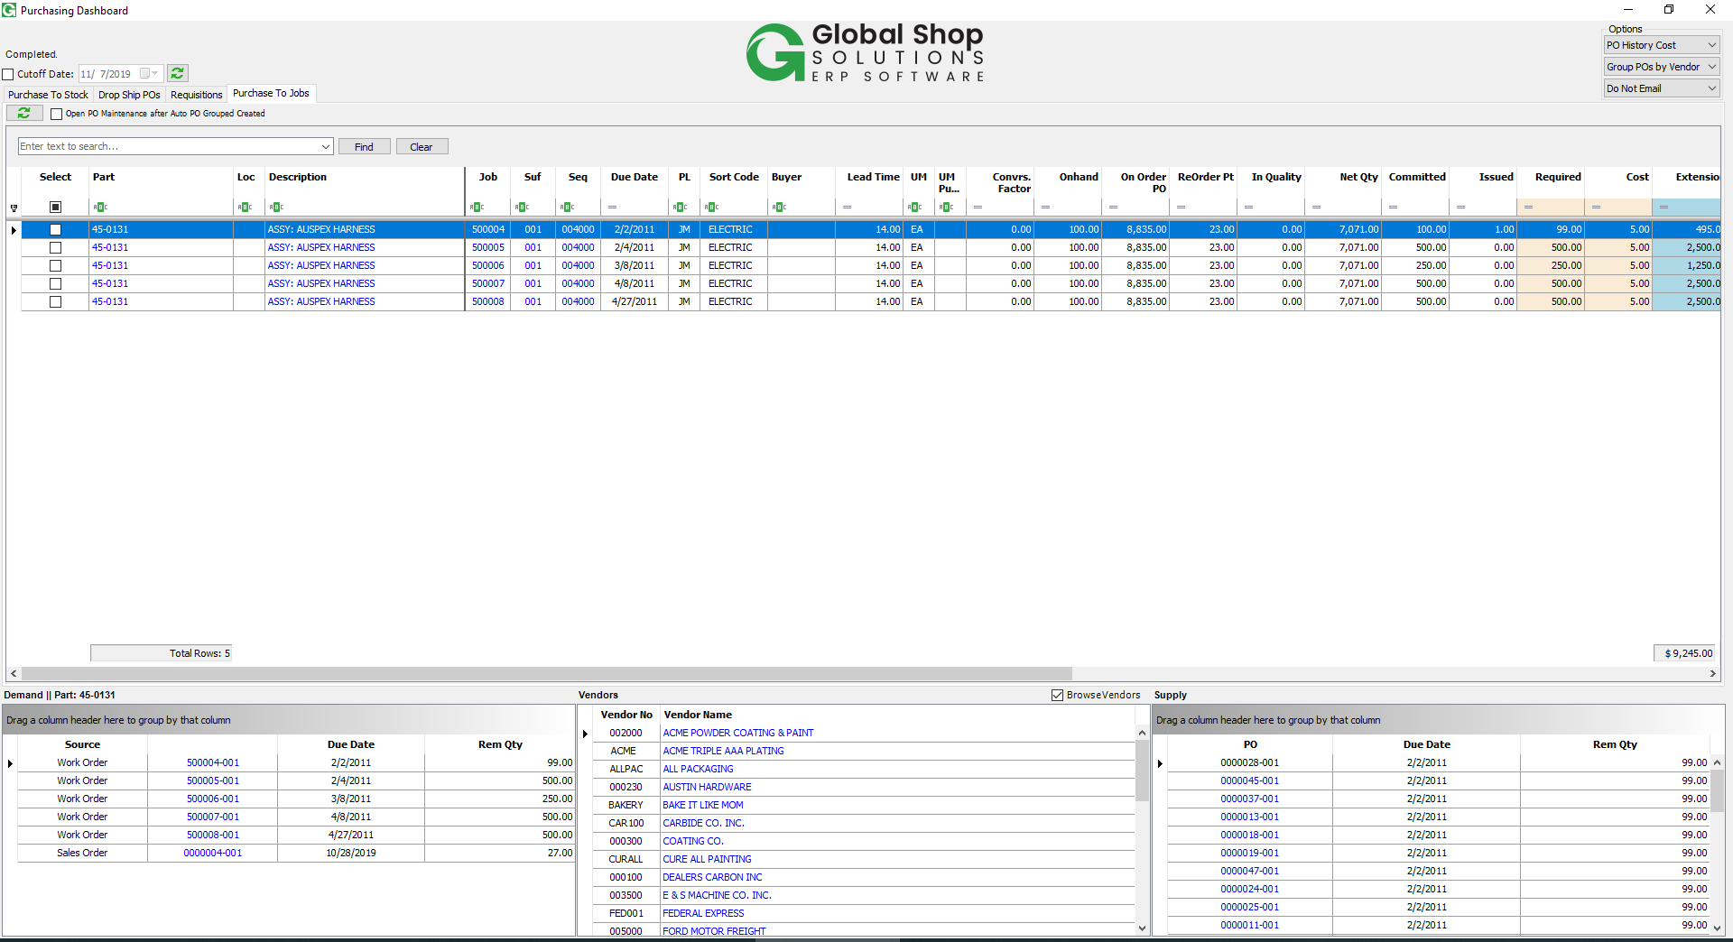

2/Clicking Description will open core Part MRP calculation

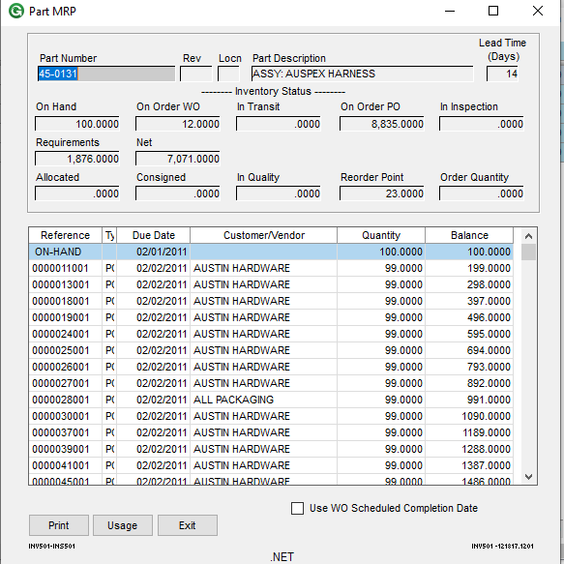

3/Click the Vendor number/name will populate the Vendor Quote, and if user selects Browse Vendors, the Vendor grid will list all the vendors so user can select a vendor to overwrite the preferred vendor displayed in the main grid for the selected record.

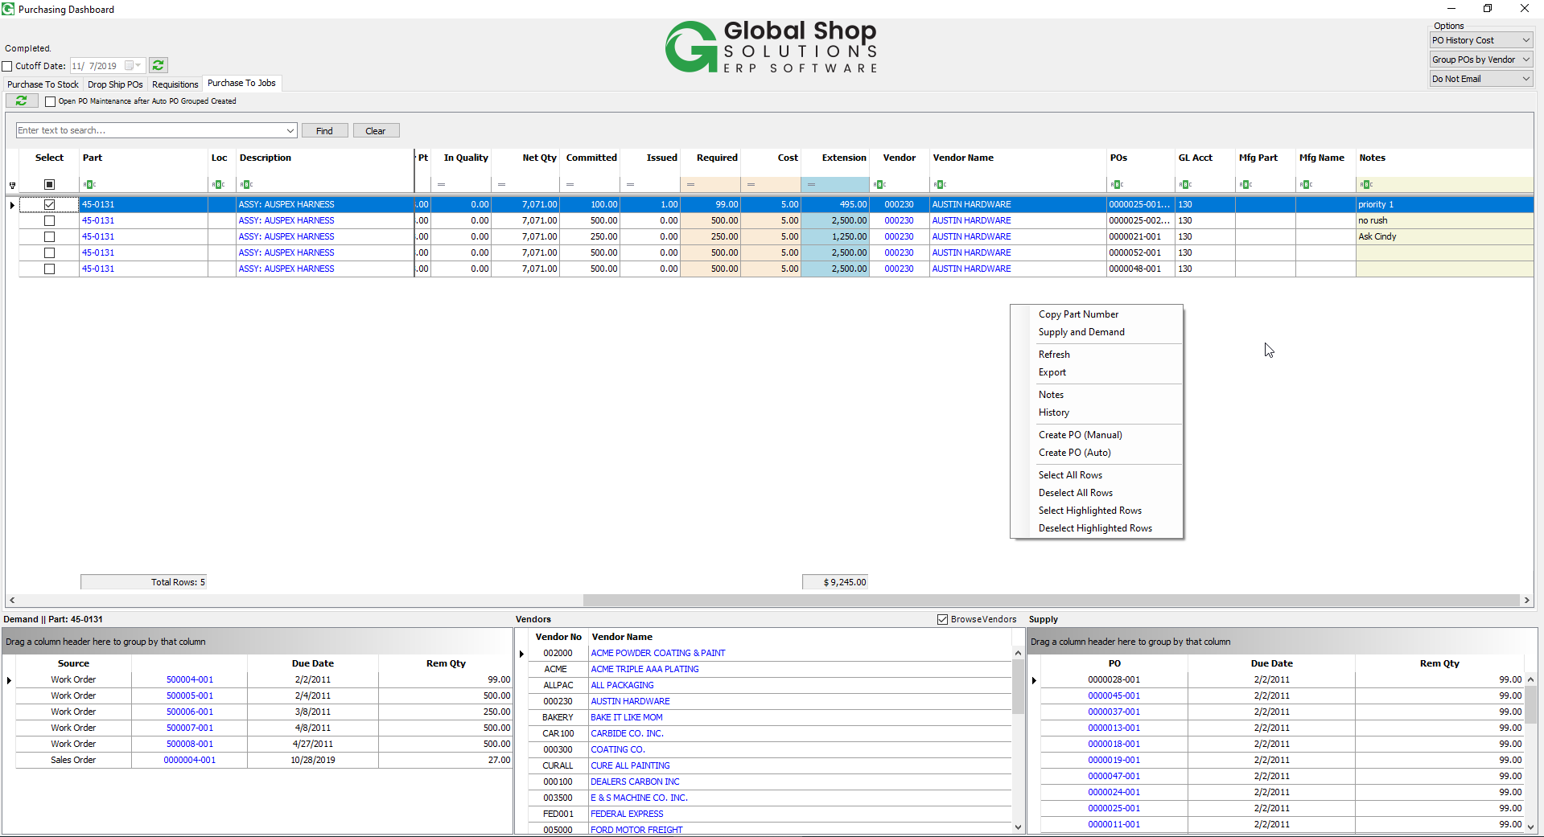

4/ Data is pulled from the Job_Commitments. Required = Committed – Issued.

The Cost is populated by **PO Hist Cost/Vendor Quote Cost/Zero Cost** based on the Options on the top right corner. User can modify the Required or Cost before cutting a PO.

The key of the **Purchase to Jobs** grid is (Job, Suffix, Sequence), but when user changes the Cost/Vendor for a record for a part, the grid will apply the Cost/Vendor for all the Job, Suffix, Sequences having that part number.

5/Context Menu Right Click has a list of selections in the picture above:

* Copy Part Number: user highlights a record then the program will copy the part number to the clipboard. If multiple records are highlighted, the parts copied will be the distinct part numbers delimited with commas.
* Supply and Demand: open the core Supply and Demand with Edit for the top row highlighted.
* Refresh: will refresh the Purchase to Jobs tab only.
* Export: export to Excel.
* Notes: Open the Notes screen for the Part, Location. The grid also has the Notes column which is the particular for the Job, Suffix, Sequence key.

Notes per Part, Location:

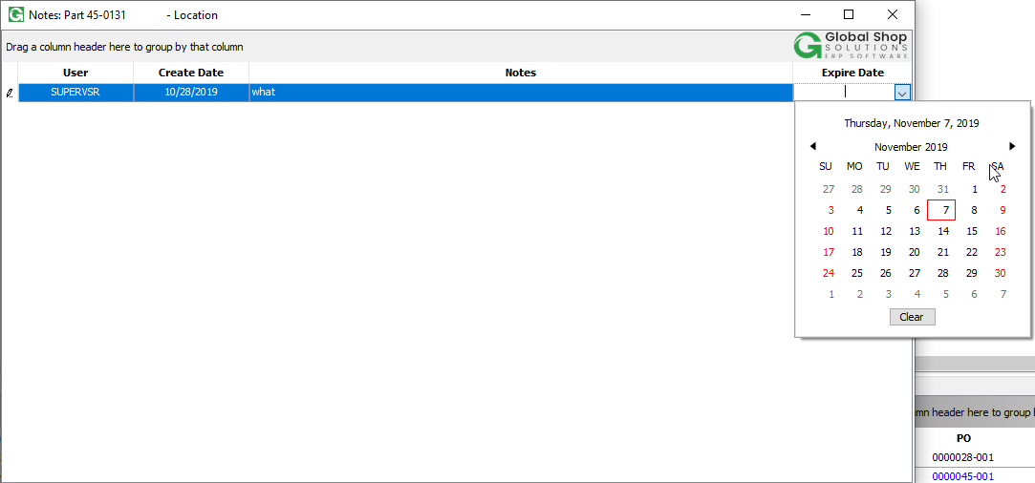

Note per Job, Suffix, Sequence:

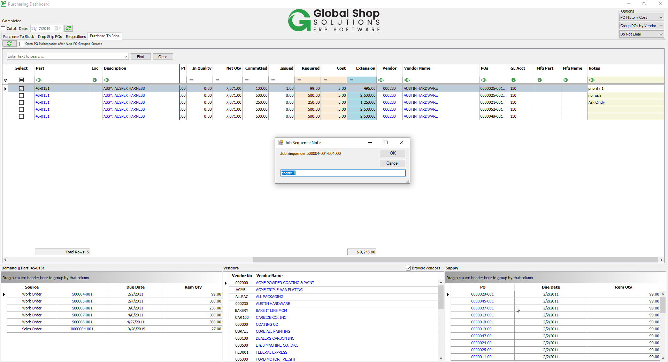

* History:

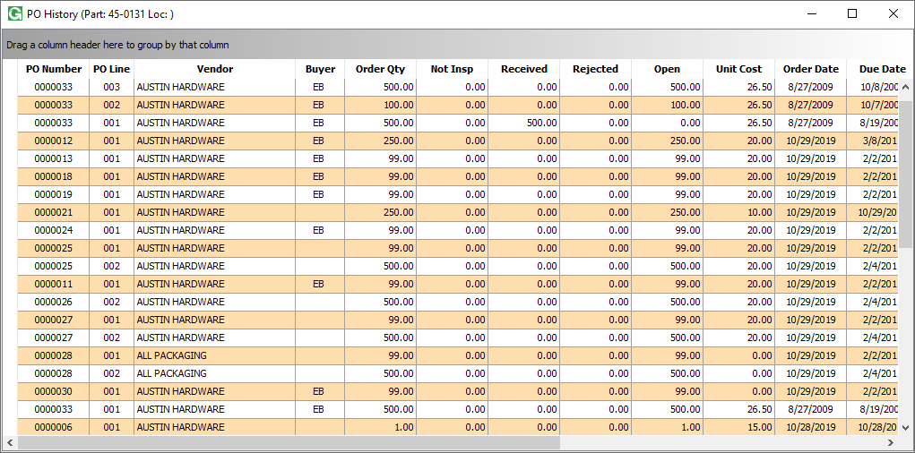

* Create PO (Manual): will open the core PO New screen populated with the preferred vendor displayed in the grid. If there is no preferred vendor in the grid, the program will ask for vendor before opening the core PO New screen. After the PO is created, the selected record will be removed from the grid. User can refresh to see the record again, and at that moment, the PO line number will be populated with that record (POs column). The record will discontinue to be displayed when the part is received and issued into the Sequence at the core PO Receipts screen. At that moment, the requirement will be removed from the Job_Commitments table, so the record is not pulled into the grid even user clicks Refresh button.
* Create PO (Auto): this selection works in combination with the top right corner options.

If “Individual POs” is selected, there will be individual PO created for each row selected.

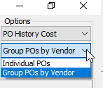

If “Group POs by Vendor” is selected, there will be only 1 PO created for the rows selected.

The PO/POs will be created, and records will be removed from the grid. If user select the “Open PO Maintenance after Auto PO Grouped Created” the core PO screen will be opened after the transaction:

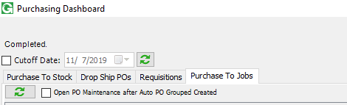

* Select/Deselect All Rows: select/deselect all records from the grid to cut POs
* Select/Deselect Highlighted Rows: to highlight multiple rows, click the row and click Ctrl to select another row. To select continued rows, click the top row, then click the Ctrl + Shift, click the last row, the range will be highlighted. This is useful for select multiple rows filtered. So user may apply a filter, then highlight the range of rows filtered and “Select/Deselect Highlighted Rows”.

6/The Copy Part Number and Supply and Demand are also added to other tab Context Menu Right Click and work similarly to the Purchase to Jobs.

Net Qty column is also added to the Purchase To Stock tab.

Net Qty = On Hand + Qty on Order PO + Qty on Order WO – Qty Required

